- We don't expect December's sharp drop in mortgage approvals to mark the start of a UK housing market downturn. December is a low activity month with a big seasonal adjustment, and this weakness will likely be revised away or prove to be a one-off. Mortgage affordability has improved significantly in recent years, and this should support solid levels of demand in 2026.
- The ONS has announced further methodological improvements for the calculation of inflation. The changes are welcome, but the fact that historical estimates will not be revised risks creating a sizeable break in the series. Factoring in changes made last spring, from 2020-2024 the average inflation outturn would be 0.3ppts lower than published figures under the new methodology.
After last week's bumper crop of data releases, the past week has been much quieter, with the Bank of England's Money & Credit release being the only data of note. The BoE reported a sharp drop in mortgage approvals to 61,013 in December, from 64,072 in November, the lowest figure for 18 months.
December's outturn came as a major surprise given the recent strength of approvals. But we think there's a good chance the big drop will either be revised away or just prove to be noise. Christmas means fewer working days and plenty of distractions from home buying, so December is typically a low activity month. This means the BoE must apply a large seasonal adjustment to the raw data – in the past ten years, the seasonally adjusted figure has been between 32%-45% higher than the non-seasonally adjusted outturn, and the December 2025 adjustment was at the lower end of this range (Chart 1).
If December's weakness persists into the busier new year market, then we would be more concerned. But our index of mortgage affordability has recovered significantly in recent years, to the extent that prices are now close to fair value. Other affordability metrics have also improved. This has left the market on a much firmer footing and though we think that the bulk of the affordability improvements are now behind us, these conditions should support solid levels of mortgage activity that are well above the lows of 2023-2024 and close to the norms seen before the pandemic.
Chart 1: The large seasonal adjustment means we place little value on December's mortgage data
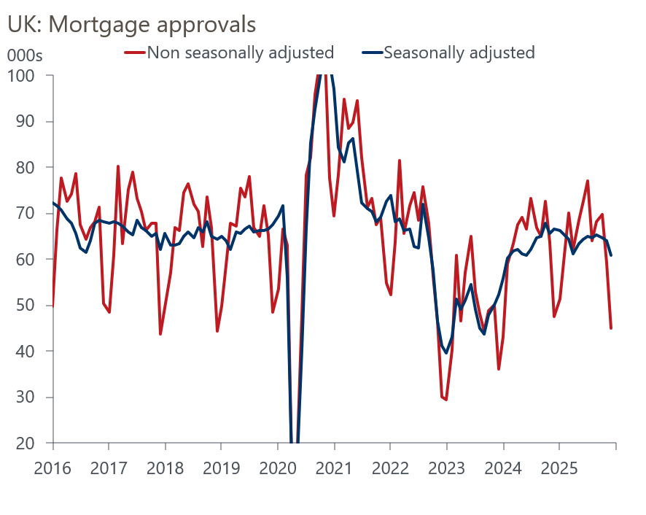
Source: Haver Analytics

The Office for National Statistics announced this week that it will implement a series of data and methodology improvements as part of its March inflation release. The three changes involve using scanner data to record grocery prices, changes to the sampling of overnight hotel stays and computer games, and improved measurement of house prices.
This is the latest in a series of improvements to the inflation data. The ONS revisions policy dictates that it will not revise the historical estimates of inflation. But it has calculated what its estimates of inflation would have looked like had the new methodology been in place over the past six years. The differences compared with the published data are material. Between 2020-2024, the average monthly inflation reading would have been 0.3ppts lower had the new methodology been followed (Chart 2).
Chart 2: Methodological changes suggest inflation has been lower than current outturns indicate
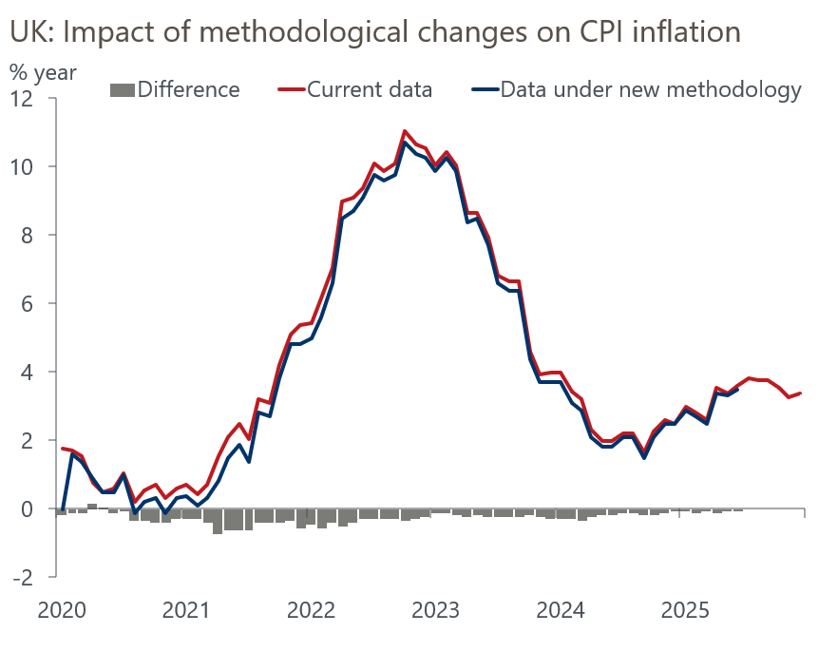
Sources: Oxford Economics calculations using data from ONS & Haver Analytics
This year's improvements are only a small part of the story at the whole economy level, with most of the differences resulting from last year's changes. But the changes to the food and non-alcoholic beverages sub-sector are larger. We are currently assessing how to incorporate the changes into our inflation forecasts. But we're minded to nudge down our forecasts given the apparent downward bias created by the changes.
On the subject of forecasting, the Bank of England published its Forecast Evaluation Report at the end of last week. The analysis was a response to one of the recommendations in Ben Bernanke's 2024 review of the BoE's macroeconomic forecasts and their role in policy preparation and communication. The report concluded that the BoE's forecasts were no worse than those produced by other forecasting models or projections published by other forecasters. But the analysis identified the labour market variables as a particular area for improvement. The report also argued that the biggest forecast errors were the result of "unforeseeable events" such as the coronavirus pandemic and Russia's invasion of Ukraine, but admitted that the persistence of inflation over recent years remains hard to explain.
Improvements to the BoE's forecasting approach will be a slow burner and we don't expect any major changes in next week's Monetary Policy Report. After December's cut, February's MPC decision looks almost certain to be a hold. Some of those who voted to cut last time around have expressed concern over the strength of forward-looking indicators of wages and prices, so will likely prefer to wait and assess the evidence from the early-2026 pay round. A 7-2 vote to keep Bank Rate at 3.75% looks the most likely outcome.

The week ahead
Next week's main event is the February meeting of the Bank of England's Monetary Policy Committee. Though the majority of MPC members have suggested they think rates will fall further, we think the chances of a February cut are very low. The most recent cut came at the last meeting, and back-to-back cuts wouldn't fit with the MPC's cautious messaging. In addition, some members who supported a cut in December have expressed concern at the strength of forward-looking indicators for pay growth. So we expect them to favour pausing until they've seen enough data on early-2026 pay settlements to address their concerns. We expect a 7-2 vote to hold Bank Rate at 3.75%.
On the data front, we will get the final results from January's S&P Global surveys. The flash survey reported much stronger activity growth, particularly across the services sector. But in recent years the results have been heavily influenced by swings in sentiment, and we think January final outturns could be slightly softer than the flash data because later respondents will have factored in last week's events surrounding Greenland.
Table 1: Week ahead calendar
Date | Events | Period | Measure | Unit | Previous | Forecast
Feb 2 | S&P Global manufacturing | Jan | PMI | % bal | 51.6 | 51.3
Feb 4 | S&P Global services | Jan | PMI | % bal | 54.3 | 54.0
Feb 4 | S&P Global composite | Jan | PMI | % bal | 53.9 | 53.6
Feb 5 | S&P Global construction | Jan | PMI | % bal | 40.1 | 41.0
Feb 5 | BoE Bank Rate decision | Feb | Bank Rate | % | 3.75 | 3.75
Source: Oxford Economics

Key forecasts
Table 2: UK forecast overview
(Annual percentage changes unless specified)
 | 2023 | 2024 | 2025 | 2026 | 2027 | 2028
GDP | 0.3 | 1.1 | 1.4 | 0.9 | 1.4 | 1.5
Private consumption | -0.3 | -0.1 | 0.9 | 1.1 | 1.1 | 1.4
Fixed investment | 0.5 | 1.7 | 3.2 | 0.9 | 2.1 | 2.1
Government consumption | 2.1 | 2.9 | 1.8 | 2.1 | 1.7 | 1.4
Exports of goods and services | -2.3 | 1.4 | 2.1 | 0.9 | 1.1 | 1.3
Imports of goods and services | -1.6 | 2.7 | 4.2 | 0.4 | 1.2 | 1.4
Industrial production | -2.6 | -1.3 | 0.5 | 0.6 | 1.1 | 1.2
Consumer prices | 7.3 | 2.5 | 3.4 | 2.3 | 2.5 | 2.3
Unemployment rate (%) | 4.1 | 4.3 | 4.8 | 5.2 | 5.0 | 4.7
Current a/c balance (% of GDP) | -3.6 | -3.0 | -2.9 | -3.0 | -2.8 | -2.6
Government balance (% of GDP) | 5.2 | 5.3 | 5.0 | 3.9 | 3.3 | 2.8
Central bank policy rate (%, EOP) | 5.25 | 4.75 | 3.75 | 3.25 | 3.00 | 2.75
10yr govt. bond yield (%, EOP) | 3.54 | 4.57 | 4.47 | 4.38 | 3.90 | 3.64
Exchange rate (US$ per £, EOP) | 1.27 | 1.25 | 1.35 | 1.29 | 1.29 | 1.29
Exchange rate (euro per £, EOP) | 1.15 | 1.21 | 1.15 | 1.11 | 1.11 | 1.11
Source: Oxford Economics
Table 3: Quarterly forecasts for the UK
 | 2025 |  |  |  | 2026
 | Q1 | Q2 | Q3 | Q4 | Q1 | Q2 | Q3 | Q4
GDP (% year) | 1.8 | 1.4 | 1.3 | 1.1 | 0.7 | 0.7 | 0.9 | 1.1
CPI inflation (% year) | 2.8 | 3.5 | 3.8 | 3.4 | 3.0 | 1.9 | 2.0 | 2.3
Bank Rate (%, EOP) | 4.50 | 4.25 | 4.00 | 3.75 | 3.75 | 3.50 | 3.50 | 3.25
10yr gilt yield (%, EOP) | 4.70 | 4.48 | 4.70 | 4.47 | 4.50 | 4.48 | 4.45 | 4.38
US$ per £ (EOP) | 1.29 | 1.37 | 1.35 | 1.35 | 1.30 | 1.29 | 1.29 | 1.29
Euro per £ (EOP) | 1.20 | 1.17 | 1.15 | 1.15 | 1.12 | 1.11 | 1.11 | 1.11
Source: Oxford Economics

Latest Country Economic Forecast:
January 22, 2026

Recent publications

Data Insights
Surprise fall in mortgage approvals in December
January PMI looks too good to be true
Quiet end to the year for the retail sector
Budget didn’t cure public finances' fragility
December's inflation pickup will prove temporary

Research Briefings
MPC preview – Rates on hold amid signs of pay stickiness
Alternative indicators point to subdued economy
Mild stagflation is likely to keep MPC divided
Will Greenland be the catalyst for a new trade war?
Why higher term premia will slow the fall in gilt yields

Contacts

Oxford Economics' UK team
- Andrew Goodwin - Chief UK Economist - agoodwin@oxfordeconomics.com
- Edward Allenby - Senior UK Economist - eallenby@oxfordeconomics.com

